 CHEMICAL ENGINEERING TRANSACTIONS  VOL. xxx, 2024 | A publication of  
The Italian Association
of Chemical Engineering
Online at www.cetjournal.it

Guest Editors: Valerio Cozzani, Bruno Fabiano, Genserik Reniers
Copyright © 2024, AIDIC Servizi S.r.l.
ISBN 979-12-81206-11-3; ISSN 2283-9216

Assessment of Air Quality in the Industrial Sector of Solofra (Southern Italy).
Daniele Sofia^{1,2}*, Rossella Girimonte¹
¹Department of Computer Engineering, Modeling, Electronics and Systems, University of Calabria, Via P. Bucci cubo 44/a Rende (CS), 87036, ITALY
²Research Department, Sense Square Srl, Corso Garibaldi 33, 84123 Salerno, Italy
*Email: daniele.sofia@unical.it

This study focuses on the assessment of air quality in the industrial sector of Solofra, particularly within the tanning industry, known for its intensive activities and potential environmental impact. The main objective is to monitor the presence of atmospheric pollutants such as particulate matter (dust), nitrogen dioxide (NO₂) and carbon monoxide (CO), due to their relevance in the industrial context of Solofra and their known adverse effects on human health and the environment.
Through advanced monitoring methods, the study identified and quantified these pollutants, revealing a significant correlation between the activities of the tanning sector and high levels of NO₂. Additionally, the detected concentrations of particulate matter and CO indicate the influence of industrial processes and combustion.
The results provide a detailed mapping of pollution sources, laying the groundwork for the development of mitigation strategies and the implementation of more effective environmental policies. This study represents a crucial step towards understanding and managing the environmental impact of industrial activities in Solofra, contributing to the protection of public health and the integrity of the local ecosystem.

  - Introduction
The interplay between industrial progress and environmental preservation has long been a topic of significant concern, highlighting the intricate balance required to foster economic development without compromising the health of our planet (Giuliano et al., 2018). The industrial sector, with its vast energy consumption, resource utilization, and waste production, stands at the forefront of this dilemma, posing considerable challenges to environmental sustainability. Among these challenges, the impact on air quality ranks highly, given its direct implications for human health and ecological systems. This study zeroes in on the assessment of air quality within the industrial sector of Solofra, a region notably marked by the presence of the tanning industry. This sector, characterized by its intensive activities, is a significant source of environmental pollutants, necessitating a closer examination of its role in atmospheric contamination (Salehi et al., 2015).
The primary objective of this investigation is to monitor and analyze the presence of key atmospheric pollutants, including particulate matter, nitrogen dioxide (NO₂), and carbon monoxide (CO), within Solofra's industrial context. These pollutants were selected for their pertinence to the area's industrial activities and their well-documented adverse effects on both human health and the environment. The study employs advanced monitoring techniques to not only detect but also quantify the levels of these pollutants, providing a clear picture of the environmental burden imposed by the tanning industry and related industrial processes.
The findings of this research reveal a significant correlation between the tanning sector's activities and elevated levels of NO₂, a revelation that underscores the substantial environmental footprint of this industry. Moreover, the detected concentrations of particulate matter and CO further highlight the broader impact of industrial operations and combustion processes on air quality. Such insights are invaluable, offering a detailed mapping of pollution sources that serves as a foundational step toward addressing the environmental challenges posed by industrial activities (Hertel et al., 1989).
By shedding light on the specific contributors to air pollution within Solofra's industrial sector, this study paves the way for the development of targeted mitigation strategies and the formulation of more effective environmental policies. The implementation of such measures is critical not only for improving air quality but also for safeguarding public health and ensuring the long-term integrity of the local ecosystem. In this regard, the research represents a crucial advancement in our understanding of the environmental implications of industrial activities, offering a pathway toward reconciling industrial development with environmental stewardship (Sofia et al., 2020).
The broader implications of this work extend far beyond the confines of Solofra, serving as a pertinent reminder of the global challenges faced in managing industrial pollution. As industries worldwide continue to evolve and expand, the lessons drawn from studies like this one become increasingly important, guiding efforts to mitigate environmental impacts and foster a more sustainable future. In essence, this research underscores the urgent need for an integrated approach to industrial planning and environmental management, one that prioritizes the health of our planet alongside economic progress.
  - Materials and methods
    - Sensy monitoring system
Sensy emerges as a state-of-the-art environmental monitoring device, ingeniously designed to cater to the growing needs for precise and real-time environmental data. Developed by leveraging cutting-edge Internet of Things (IoT) technologies, Sensy stands out for its comprehensive approach to environmental sensing, capable of capturing a wide array of data points crucial for understanding and responding to environmental changes and challenges.
At the heart of Sensy lies a diverse suite of sensors, each meticulously selected for its reliability and accuracy. These sensors are sourced from industry leaders such as Sensirion, SeedStudio, Winsen, and Hongyuv, ensuring that Sensy delivers on its promise of precision. The device is capable of monitoring temperature, humidity, atmospheric pressure, particulate matter (PM1, PM2.5, and PM10), gases (NO₂, CO, O₃), wind speed and direction, and even solar radiation. This broad spectrum of measurements makes Sensy an invaluable asset in a variety of applications, from urban air quality monitoring to climate research.
The technological foundation of Sensy is noteworthy, utilizing Band-Gap technology for temperature measurements, capacitive technology for humidity, and Laser Scattering for particulate matter detection. Gas concentrations of NO₂ and CO are measured using MOx technology, while O₃ levels are captured through electrochemical technology. Wind parameters are accurately gauged using ultrasonic technology, and solar radiation is measured with a pyrometer. These advanced technologies ensure that Sensy provides data with high accuracy, such as ±0.3°C for temperature, ±3% for humidity, and ±5 μg/m³ for particulate matter, among others. Designed for versatility, Sensy can be deployed in both fixed infrastructure settings and dynamic applications, offering flexibility for outdoor environmental monitoring. Its casing, made from ABS plastic with UV protection and produced using Injection Molding technology, ensures durability and resilience against environmental factors, making Sensy suitable for long-term deployment in varied environmental conditions.
The integration of proprietary firmware and software within Sensy streamlines data processing and transmission, allowing for the seamless collection, analysis, and sharing of environmental data. This integration not only enhances the operational efficiency of the device but also ensures the security of the data transmitted, addressing one of the key concerns in IoT applications.


1 cm
Figure 1: Sensy monitoring system.
Table 1: Sensy monitoring system features
Data Product | Parameter | Accuracy | Technology
MicroClima | Temperature | ± 0.3 °C | Band-Gap
 | Humidity | ± 3 % | Capacitive
 | Pressure | ± hPa | Capacitive
Particulate matter | PM10 | ± 5 μg/m³ | Laser Scattering
 | Pm2.5 | ± 5 μg/m³ | Laser Scattering
 | PM1 | ± 5 μg/m³ | Laser Scattering
Gas | NO₂ | ± μg/m³ | MOx
 | CO | ± μg/m³ | MOx
 | O₃ | ± 0.01 ppm | Electrochemical
Wind | Speed | ± 5 % m/s | Ultrasound
 | Direction | ± 0.3 ° | Ultrasound

    - Wastewater treatment plant
The wastewater treatment plant for the tanneries in Solofra is a notable example of how the tanning industry, known for its environmental impact, can adopt advanced technologies to mitigate pollutant emissions and promote environmental sustainability. Solofra, located in southern Italy, is renowned for its long-standing tradition in the tanning industry, a sector that has significantly contributed to the local economy but also posed considerable environmental challenges in terms of wastewater management.
Designed specifically to address the complex issues associated with the disposal of tannery effluents, which are characterized by a wide range of pollutants including chromium, sulfates, fats, and other chemicals used in the tanning process, the treatment plant in Solofra plays a crucial role in preventing the contamination of local water resources and protecting the environment and public health.
The treatment process at the Solofra plant is divided into several stages, each aimed at eliminating specific types of pollutants:
- Preliminary treatment: This initial phase involves removing larger solid residues and floating materials using screens and grates. This step is essential to protect the equipment in the subsequent phases from damage or blockages.
- Primary treatment: Through sedimentation, suspended solids are separated from the water. This stage is particularly important for reducing the load of organic and inorganic matter present in the wastewater.
- Secondary treatment: This is the key phase of the process, where biological treatment of the water takes place. Specific microorganisms decompose dissolved organic matter. This step may include aeration systems that supply the oxygen necessary for bacteria to carry out their metabolic processes.
- Tertiary treatment: In this phase, advanced treatments are performed to remove residual pollutants, such as heavy metals (including chromium), not eliminated in the previous stages. These treatments can include filtration processes, adsorption on activated carbon, or reverse osmosis techniques, ensuring high-quality final water that can sometimes be reused in the production process or for other purposes.
- Sludge management: The sludge produced during the treatment undergoes further stabilization, dehydration, and sometimes valorization processes to reduce its volume and facilitate safe disposal or reuse in agricultural or energy applications.
The wastewater treatment plant in Solofra stands out for its ability to integrate advanced technologies and innovative solutions to tackle the environmental challenges of the tanning industry. Its implementation demonstrates the commitment of the community and local businesses to environmental sustainability and the protection of water resources, serving as a reference model for other industrial realities in Italy and abroad.

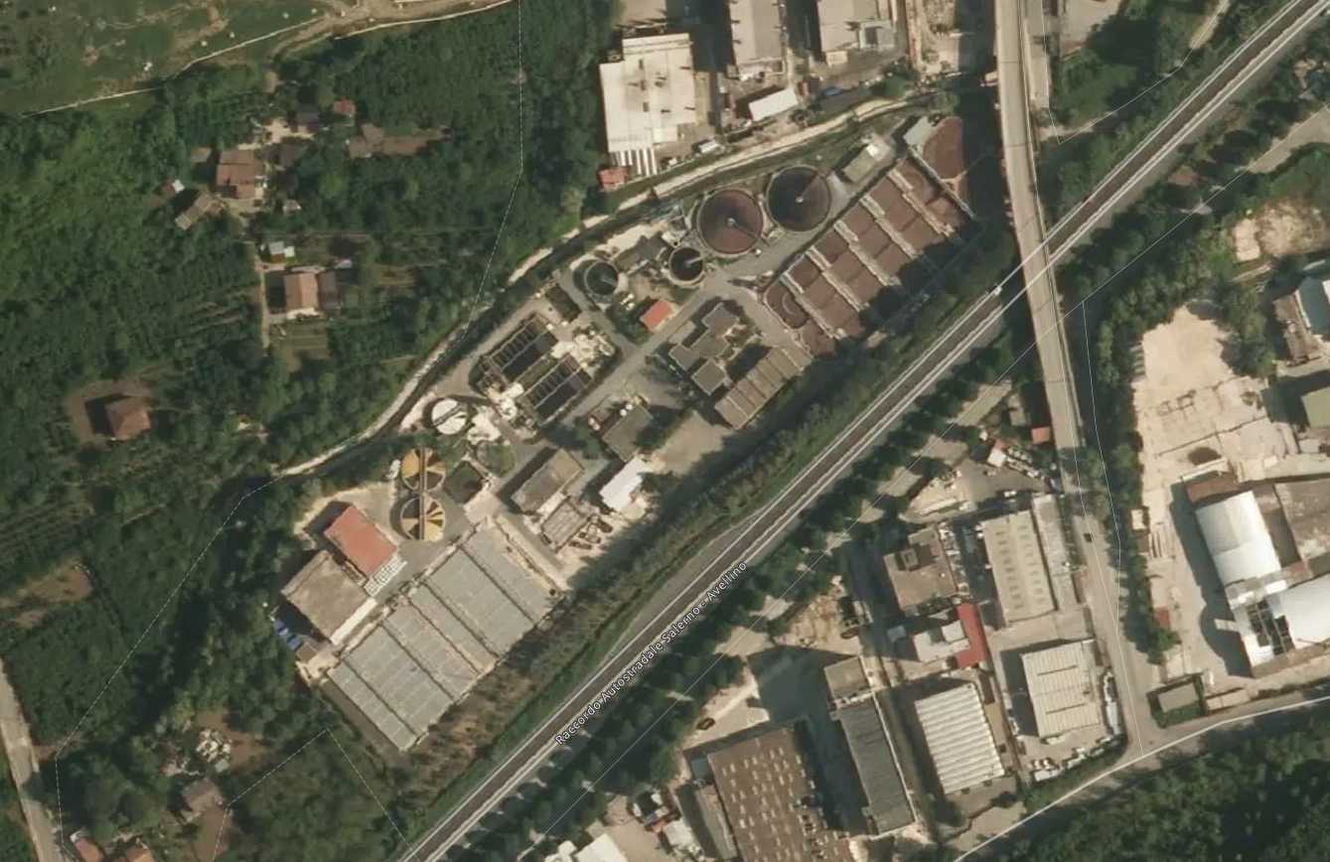
Monitoring point

Monitoring value boundary
4
1
2
3
Figure 2: Water treatment plant of the Solofra tanneries with the points where the control units have been installed highlighted.
    - AISI (Artificial Intelligence for the Pollution Source Identification)
AISI begins by mapping the area to be monitored through the setup of a series of air quality monitoring stations, assuming a distribution of one station every 1-3 km². The points to be analyzed are arranged in such a way as to form a number of adjacent triangles (a mesh), as shown in figure 2, having one side of the triangle in common, that is, two sensors. At each monitoring station, data on air quality and meteorological parameters such as wind strength and direction, relative humidity, atmospheric pressure, and pollutant concentrations are collected (Lotrecchiano et al., 2022). Data related to air quality and monitored weather conditions are analyzed by calculating the average pollution threshold based on historical data related to the mesh. To define the mesh, the measurement device where the greatest deviation from the threshold limit identified by Legislative Decree 155/2010 occurs is considered, the final goal of the study is identify the position of the atmospheric pollution source. Further details on the AISI model are explored in depth in the work of Lotrecchiano et al., 2022.
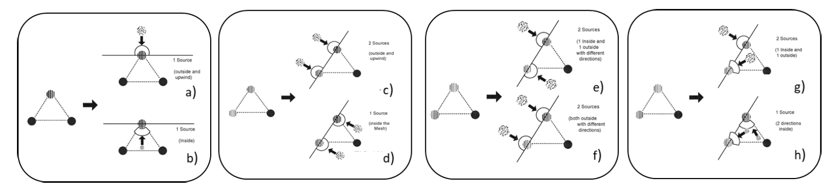
Figure 3: Case in which a-b) only one and c-h) two of the three stations of the same mesh indicate an increase in the concentration of the pollutant.

  - Results
    - Analysis of monitoring data with AISI

Table 2: Monitoring time traces
n° |  | Monitoring tracks |  | Wind Direction ° N=0
1 | 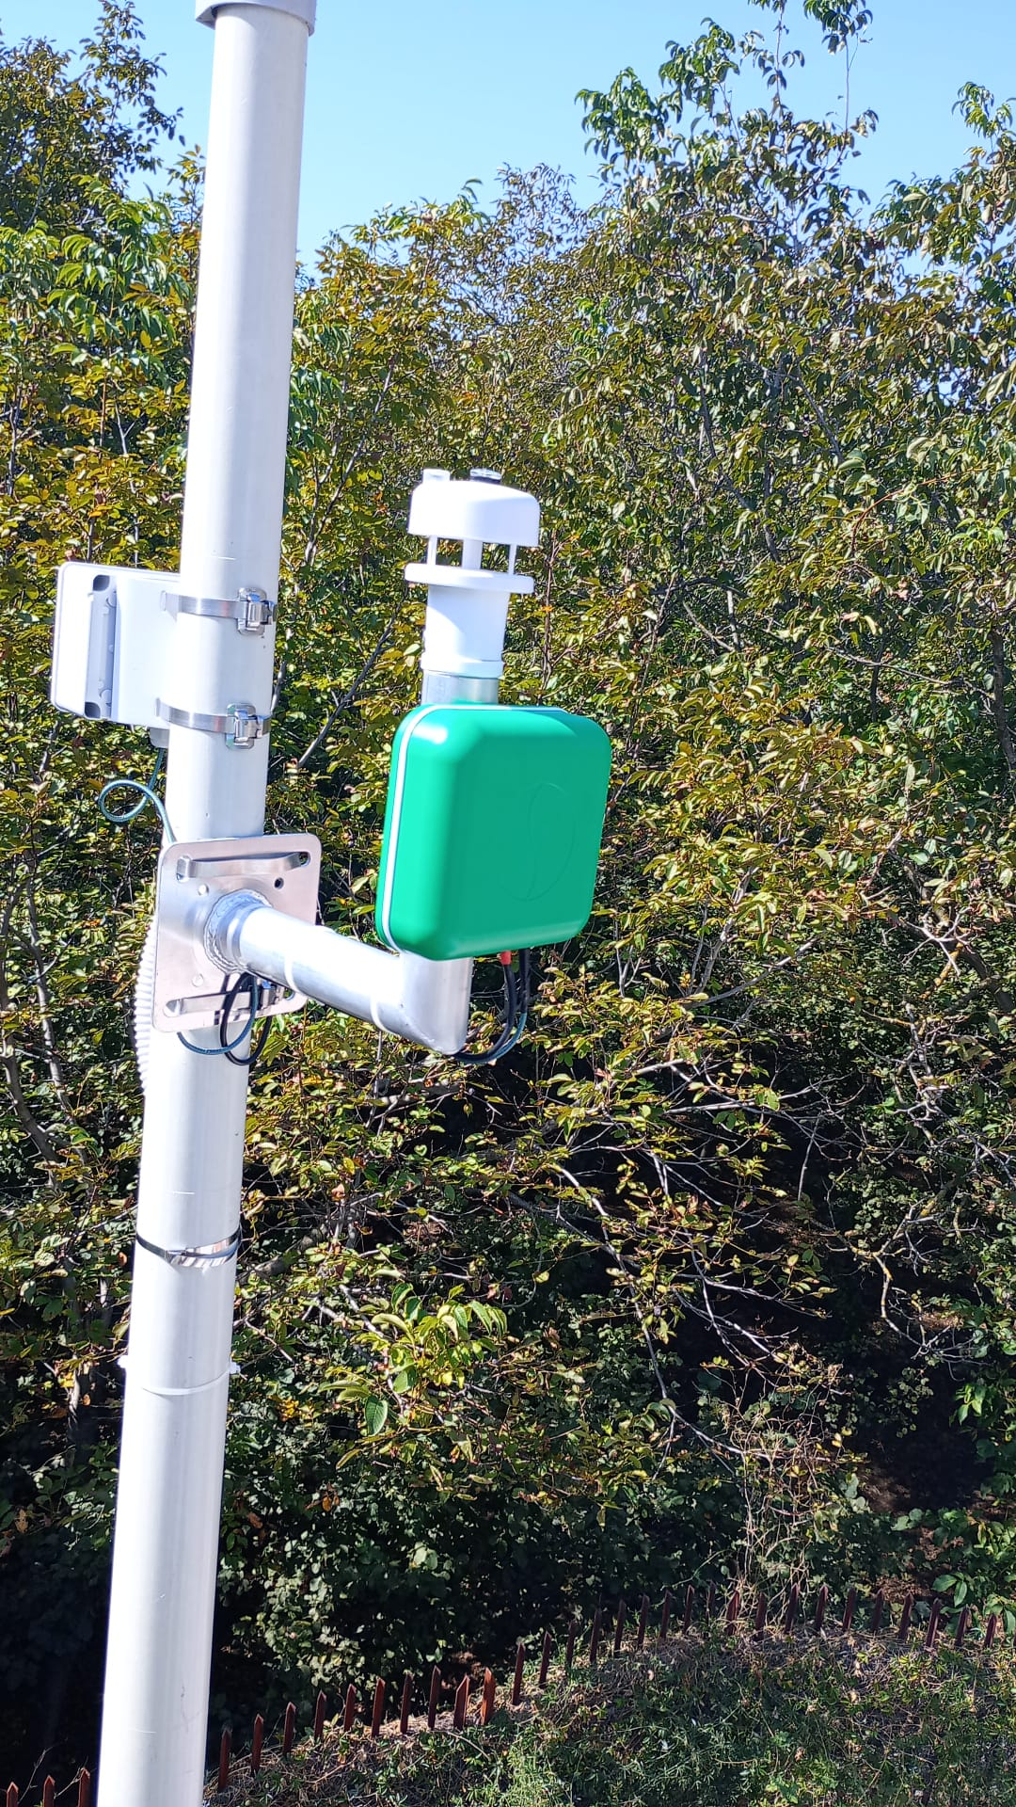 | 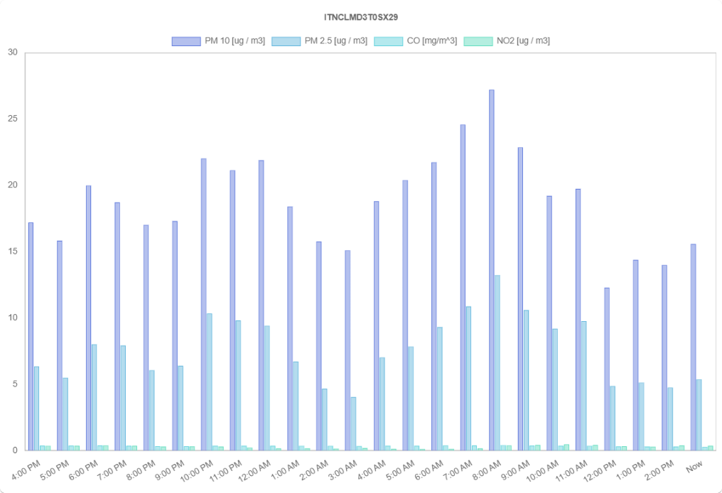 |  | 1= 68,2 13= 74,7  2= 91,1 14= 77,2  3= 141,8 15= 65,3  4= 125,8 16= 57,8  5= 97,2 17= 74,3  6= 113,6 18= 61,0  7= 85,3 19= 77,2  8= 46,6 20= 67,5  9= 60,1 21= 77,4  10= 47,0 22= 92,0  11= 41,2 23= 88,7  12= 58,3 24= 64,1
2 |  | 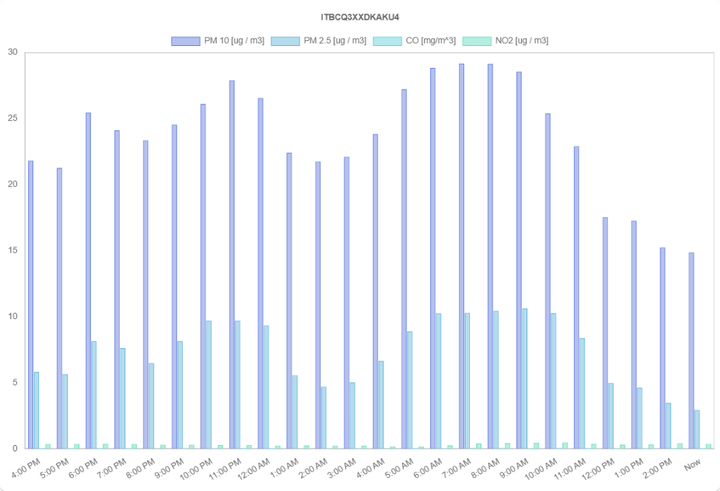 |  | 1= 198,2 13= 183,6  2= 260,3 14= 189,5  3= 170,6 15= 155,7  4= 125,3 16= 222,1  5= 191,0 17= 144,9  6= 172,6 18= 115,2  7= 147,6 19= 171,5  8= 213,8 20= 206,6  9= 202,1 21= 162,2  10= 140,0 22= 149,2  11= 180,5 23= 140,2  12= 199,8 24= 153,9
3 | 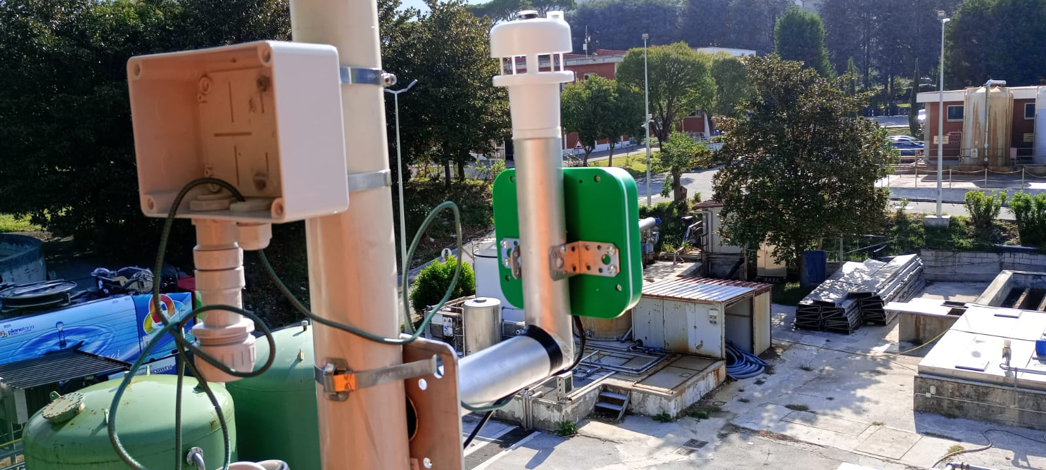 | 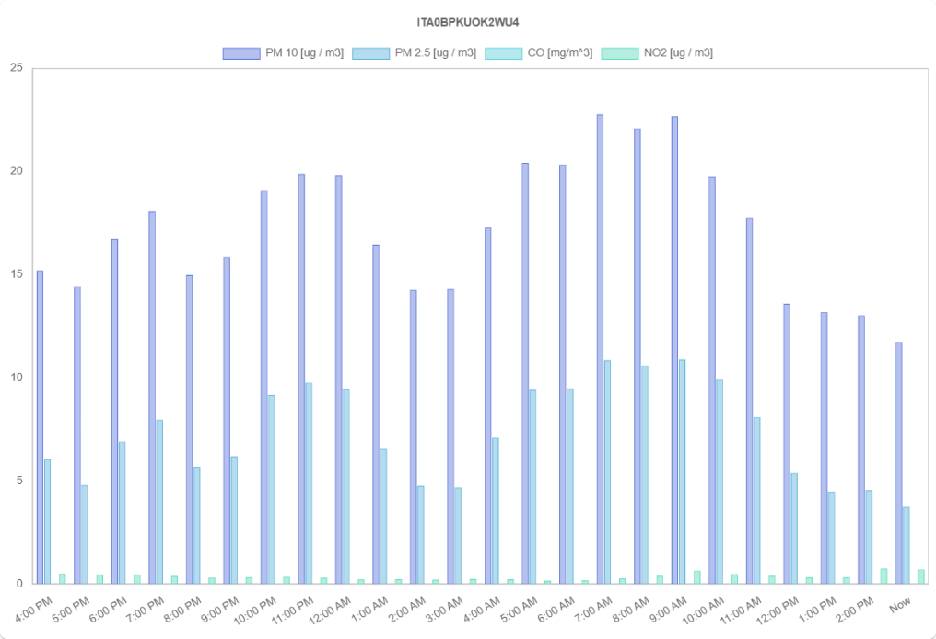 |  | 1= 91,8 13= 79,9  2= 133,2 14= 116,8  3= 155,7 15= 89,3  4= 131,2 16= 107,3  5= 164,0 17= 67,1  6= 99,5 18= 101,0  7= 110,9 19= 84,2  8= 86,4 20= 91,6  9= 88,0 21= 117,9  10= 81,7 22= 113,4  11= 88,7 23= 96,5  12= 88,2 24= 119,5
4 | 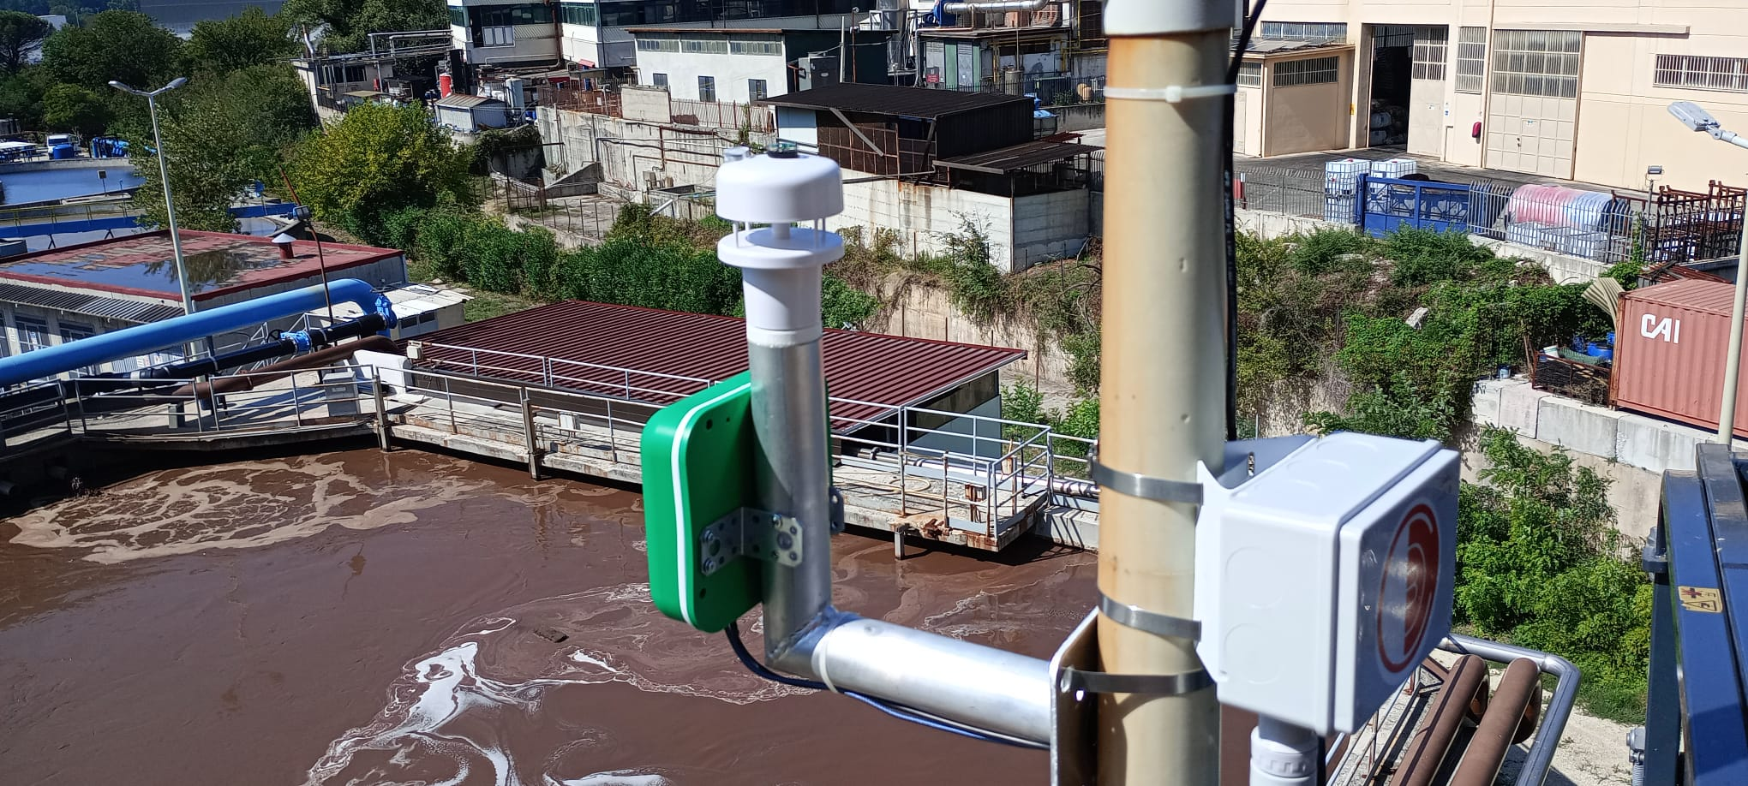 | 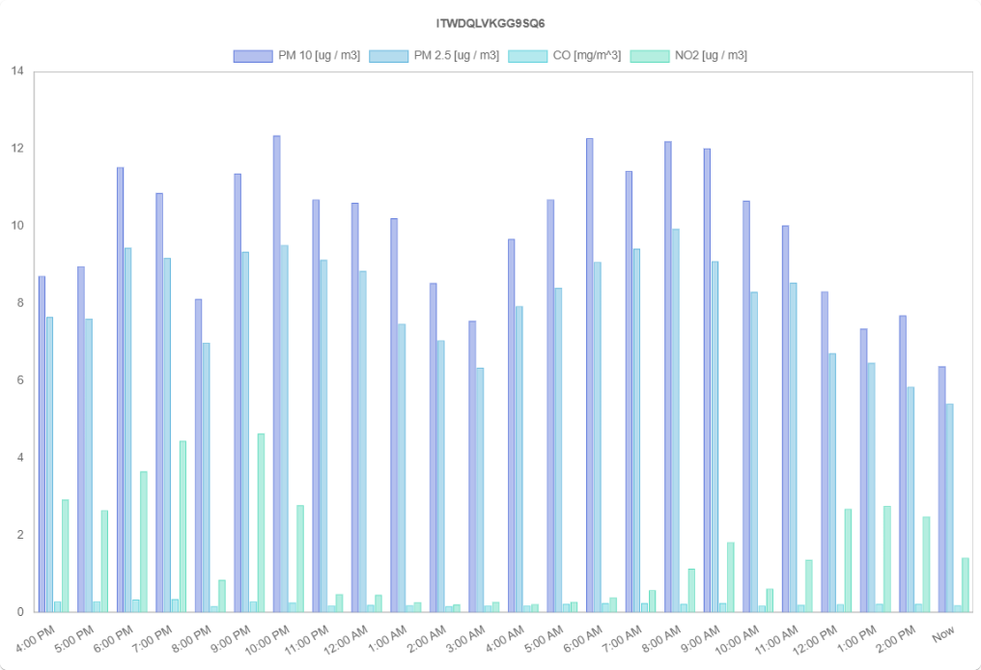 |  | 1= 104,9 13= 94,7  2= 173,3 14= 70,2  3= 169,9 15= 81,7  4= 105,3 16= 79,0  5= 156,8 17= 76,5  6= 88,4 18= 92,5  7= 81,5 19= 92,0  8= 106,7 20= 105,1  9= 85,3 21= 150,8  10= 81,7 22= 124,7  11= 76,1 23= 99,5  12= 95,4 24= 111,8
The data presented in Table 2 were instrumental in utilizing the AISI model to identify the points within the process that are responsible for the highest pollutant emissions. This approach was specifically designed to pinpoint areas of concern within the industrial operation, allowing for a targeted analysis of emission sources. To ensure that the analysis reflected a typical operational routine of the plant, a weekday was selected for data collection. This choice was made to capture the plant's activities under normal working conditions, thereby providing a representative overview of its environmental impact during a standard operational cycle. This methodological decision ensures that the findings and subsequent recommendations for emission reduction are both relevant and applicable to the plant's daily operations.
The study focused on confirming high pollution levels at specific, predicted critical points based on wind direction. Future research could expand on these findings by incorporating control sites to offer a comparative baseline and further validate sensor placements.
  - Conclusions
The data analyzed through the AISI model, based on measurements taken during a typical weekday, have provided precise and valuable insights into the points in the industrial process where pollutant emissions are at their highest. This targeted diagnostic approach is a crucial advancement in environmental monitoring, as it allows for the pinpointing of critical areas where interventions can be most effective. Such detailed mapping is instrumental in identifying specific sources of emissions and understanding their impacts, which in turn facilitates the development of tailored mitigation strategies.
These findings underscore the significance of deploying specialized monitoring systems and adhering to well-defined operational routines. By systematically collecting and analyzing environmental data, industries can gain a clearer picture of their emissions landscape. This structured approach not only helps in complying with environmental regulations but also plays a vital role in continuous improvement efforts aimed at pollution reduction.
The study highlights the benefits of integrating advanced technological solutions like the AISI model into regular industrial operations. This integration fosters a proactive approach to environmental management, where potential issues can be addressed swiftly and efficiently before they escalate into larger problems. The proactive identification of pollution hotspots is particularly beneficial for making informed decisions about where to allocate resources and how to engineer modifications in production processes to minimize harmful outputs.

Nomenclature
PM10 – particulate matter 10 micrometers or less in diameter, mg m⁻³

PM2.5 – particulate matter 2.5 micrometers or less in diameter, mg m⁻³
PM1 – particulate matter 1 micrometers or less in diameter, mg m⁻³

Acknowledgments
We wish to express our profound gratitude to the team at Sense Square for making this study possible.

References

Giuliano A., Gioiella F., Sofia D., Lotrecchiano N., 2018, A novel methodology and technology to promote the social acceptance of biomass power plants avoiding Nimby Sindrome, Chem. Eng. Trans., 67, 307-312. DOI: 10.3303/CET1867052.
Hertel O. and Berkowicz R., 1989a: Modeling pollution from traffic in a street canyon: Evaluation of data and model development. DMU Luft-A 129, National Environmental Research Institute, Denmark, 77pp. OSPM User’s guide, vergina.eng.auth.gr/mech/lat/copert/copert.htm
Lotrecchiano N., Barletta D., Poletto M., Sofia D., 2022, Artificial Intelligence for the Pollution Source Identification, Chem. Eng. Trans. 96, 439-444. DOI: 10.3303/CET2296074
Lotrecchiano N., Sofia D., Giuliano A., Barletta D., Poletto M., 2020, Pollution dispersion from a fire using a Gaussian plume model, International Journal of Safety and Security Engineering 10, 431-439. DOI: 10.18280/ijsse.100401
Salehi Kahrizsangi H., Sofia D., Barletta D., Poletto M., 2015, Dust generation in vibrated cohesive powders, Chem. Eng. Trans. 43, 769–774. DOI: 10.3303/CET1543129
Sofia D., Lotrecchiano N., Trucillo P., Giuliano A., Terrone L., 2020, Novel air pollution measurement system based on ethereum blockchain, J. Sens. Actuator Netw. 2020, 9(4), 49. DOI: 10.3390/jsan9040049

